HYDROGEN ROMANTIC
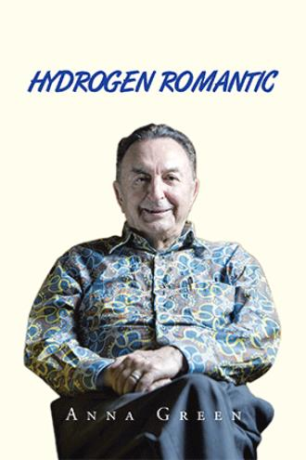
by Anna Green

About the Book
The idea of the Hydrogen Romantic book came to my mind after working for several years with the leading hydrogen energy scientists and observing their activities. One of those scientists, Dr. Turhan Nejat Veziroglu, has devoted his life to this topic, becoming much loved and respected around the world. In addition to all the momentous events in which Dr. Veziroglu has been involved, his memories are very interesting. Such a life is almost like navigating the pages of history, allowing admirers to gain information without being bored. I asked him to spend one hour with me every day, so I could interview him. During those one-hour periods, I asked him questions, and I recorded his responses. After I finished the interviews, I listened to the recordings. From this, I wrote the book. In addition, I did research on the sections dealing with the historical events. I've added this research as narratives in the book.
Book Details
Language : English
Publication Date : 12/29/2020
Format : Softcover
Dimensions : 6x9
Page Count : 286
ISBN : 9781664126992
Format : Hardcover
Dimensions : 6x9
Page Count : 286
ISBN : 9781664127005
Format : E-Book
Dimensions : N/A
Page Count : 286
ISBN : 9781664126985

Softcover Hardcover E-Book

$17.99 $31.99 $3.99

https://www.xlibris.com/en/bookstore/bookdetails/759083-hydrogen-romantic

